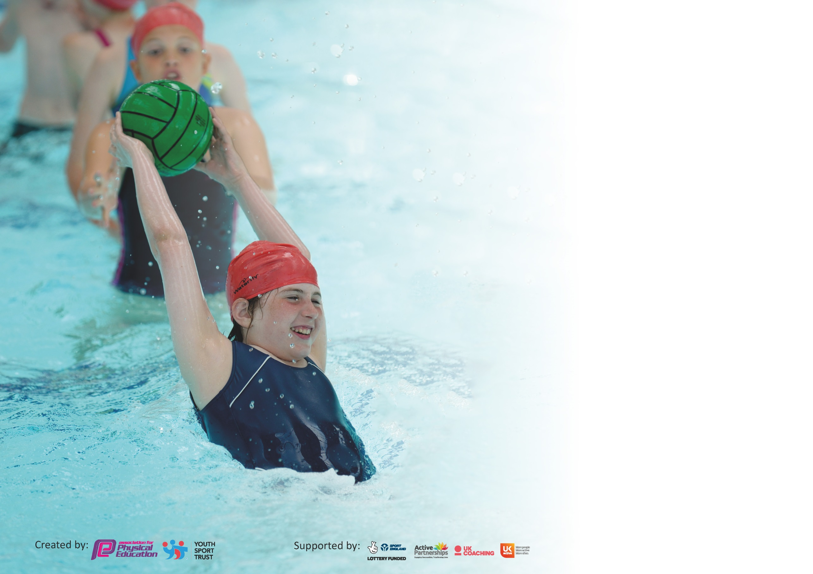

It is important that your grant is used effectively and based on school need. The Education Inspection Framework (Ofsted 2019 p64) makes clear there will be a focus on ‘whether leaders and those responsible for governors all understand their respective roles and perform these in a way that enhances the effectiveness of the school’.

Under the Quality of Education criteria (p41) inspectors consider the extent to which schools can articulate their curriculum (INTENT), construct their curriculum (IMPLEMENTATION) and demonstrate the outcomes which result (IMPACT).

To assist schools with common transferable language this template has been developed to utilise the same three headings which should make your plans easily transferable between working documents.

Schools must use the funding to make additional and sustainable improvements to the quality of Physical Education, School Sport and Physical Activity (PESSPA) they offer. This means that you should
use the Primary PE and Sport Premium to:

- Develop or add to the PESSPA activities that your school already offer
- Build capacity and capability within the school to ensure that improvements made now will benefit pupils joining the school in future years

Please visit gov.uk for the revised DfE guidance including the 5 key indicators across which schools should demonstrate an improvement. This document will help you to review your provision and to report your spend. DfE encourages schools to use this template as an effective way of meeting the reporting requirements of the Primary PE and Sport Premium.

We recommend you start by reflecting on the impact of current provision and reviewing the previous spend.

Schools are required to publish details of how they spend this funding as well as on the impact it has on pupils’ PE and sport participation and attainment by the end of the summer term or by 31st July 2020 at the latest.

We recommend regularly updating the table and publishing it on your website throughout the year. This evidences your ongoing self-evaluation of how you are using the funding to secure maximum, sustainable impact. Final copy must be posted on your website by the end of the academic year and no later than the 31st July 2020. To see an example of how to complete the table please click HERE.

Support for review and reflection - considering the 5 key indicators from DfE, what development needs are a priority for your setting and your pupils now and why? Use the space below to reflect on previous spend and key achievements and areas for development.

Key achievements to date until July 2019: | Areas for further improvement and baseline evidence of need:
- 2 Hours of timetabled curriculum PE for every class EYFS-Key Stage 2 delivered by an in-house PE specialist.  - Every pupil has the opportunity to take part in healthy competition during PE curriculum time.  - 100% of KS2 children taking part in Inter-school indoor athletics competition using specialist facilities.  - 100% of whole school taking part in reindeer run to support local charity  - KS2 football team run by year 6 pupils with organised fixtures with local schools  - Training for playleaders started (just prior to lockdown) | - Improve playtime and lunchtime provision; more structure, increased engagement of MDS, year 6 sports leaders  - Further CPD for non specialist teachers  - Socially distances lesson development across the school  - Continue to increase number of children in extra-curricular sports clubs and children representing the school in competitions  - The profile of sport needs to be raised amongst children in the community  - Some children’s opportunities outside of school are limited due to time/costs and family circumstances

Meeting national curriculum requirements for swimming and water safety.
What percentage of your current Year 6 cohort swim competently, confidently and proficiently over a distance of at least 25 metres?  N.B. Even though your pupils may swim in another year please report on their attainment on leaving  primary school at the end of the summer term 2020. | 78%
What percentage of your current Year 6 cohort use a range of strokes effectively [for example, front crawl, backstroke and breaststroke]? | 67%
What percentage of your current Year 6 cohort perform safe self-rescue in different water-based situations? | 28%
Schools can choose to use the Primary PE and Sport Premium to provide additional provision for swimming but this must be for activity over and above the national curriculum requirements. Have you used it in this way? | No – Due to Covid-19

Action Plan and Budget Tracking
Capture your intended annual spend against the 5 key indicators. Clarify the success criteria and evidence of impact that you intend to measure to evaluate for pupils today and for the future.

Academic Year: 2019/20 | Total fund allocated: £17500 | Date Updated:17/7/2020
Key indicator 1: The engagement of all pupils in regular physical activity – Chief Medical Officer guidelines recommend that primary school pupils undertake at least 30 minutes of physical activity a day in school |  |  |  | Percentage of total allocation:
 |  |  |  | %
Intent | Implementation |  | Impact
Your school focus should be clear what you want the pupils to know and be able to do and about  what they need to learn and to  consolidate through practice: | Make sure your actions to achieve are linked to your intentions: | Funding allocated: | Evidence of impact: what do pupils now know and what can they now do? What has changed?: | Sustainability and suggested next steps:
WOW Living streets  Swimming for Year 5  Leadership is promoted through PE lessons – children to take the lead of aspects of the sessions. Children coach each other and share their skills  Activ8 playground audit | Whole school assembly to look at ways to be active and use the trip to school for that reason. Encourage healthy families.  All year 5 children to attend swimming lessons at Arundel Lido for Summer 1 and 2  Activ8 to provide leadership training  Playground re organised into Zones and areas, resourced and training given to TA’s and play leaders | £200  £800  £500  £2500 | All children at The Laurels to have the opportunity to take part by walking to school and submitting data, as a result receive badges to recognise their success.  All children are able to swim 25m by the end of year 6  Developing sense of responsibility  All children have active time during playtimes using appropriate equipment | Continue into next year and link in with the travel plan.  Top required for year 6 due to Covid-19  Continued to be embedded into PE lessons across the school  Re train play leaders due to current children leaving and school closure
Key indicator 2: The profile of PESSPA being raised across the school as a tool for whole school improvement |  |  |  | Percentage of total allocation:
 |  |  |  | %
Intent | Implementation |  | Impact
Your school focus should be clear what you want the pupils to know and be able to do and about  what they need to learn and to  consolidate through practice: | Make sure your actions to achieve are linked to your intentions: | Funding allocated: | Evidence of impact: what do pupils now know and what can they now do? What has changed? | Sustainability and suggested next steps:
Employment of PE specialist during the Autumn term teaching PE from EYFS to Year 6.  Power of PE scheme purchased for whole school delivery of PE (for non specialist)  Skills progression document created in line with the facilities available at school and being able to use at the High school  Resources | All children receive 2 hours of timetabled curriculum PE per week from PE specialist  Instil Physical Education at the heart of School life, one way we aim to achieve this is by creating robust cross-curricular links in progressive P.E lessons.  Specific curriculum resources to target a wider range of sports (as detailed in the PE scheme | £8500  £1000  £500  £1500 | Pupil voice  48% of children in key stage 2, stated PE was their favourite subject at school.  37% (+32 Children) of children in key stage 2, stated they like PE 14% (+4 Children) of children stated they sometimes like PE.  Only 1% of children said they did not enjoy PE lessons.  Without the PE specialist, teachers are confident at delivering the PE lessons and are clear with the progression and building on prior knowledge.  High quality resources in PE lessons measured through observation of children’s skills, knowledge and physical ability. | SLT have noted the positive impact of a specialist PE teacher on PE delivery across the school  High engagement of children in PE lessons even those without kit  CPD required for specific teachers on certain skills development areas.  Continued support for all staff (including TA’s)

Key indicator 3: Increased confidence, knowledge and skills of all staff in teaching PE and sport |  |  |  | Percentage of total allocation:
 |  |  |  | %
Intent | Implementation |  | Impact
Your school focus should be clear | Make sure your actions to | Funding | Evidence of impact: what do | Sustainability and suggested
what you want the pupils to know | achieve are linked to your | allocated: | pupils now know and what | next steps:
and be able to do and about | intentions: |  | can they now do? What has
what they need to learn and to |  |  | changed?:
consolidate through practice:
Developing confidence, knowledge and skills of staff in PE | PE subject leader attend PE courses and conferences throughout the school year. After each course, the leader(s) will feedback to all staff members and make any resources available to staff. The leader(s) will regularly liaise with less confident staff members regarding delivering PE. | £500 | Staff more able and confident of delivering high quality PE lessons. | Ongoing support via the MAT
Key indicator 4: Broader experience of a range of sports and activities offered to all pupils |  |  |  | Percentage of total allocation:
 |  |  |  | %
Intent | Implementation |  | Impact
Your school focus should be clear | Make sure your actions to | Funding | Evidence of impact: what do | Sustainability and suggested
what you want the pupils to know | achieve are linked to your | allocated: | pupils now know and what | next steps:
and be able to do and about | intentions: |  | can they now do? What has
what they need to learn and to |  |  | changed?:
consolidate through practice:
Broadening offer of sports activities | We offer a range of extra-curricular activities and clubs – Outdoor project, Football, Multi skills, Dance

Key indicator 5: Increased participation in competitive sport |  |  |  | Percentage of total allocation:
 |  |  |  | %
Intent | Implementation |  | Impact
Your school focus should be clear | Make sure your actions to | Funding | Evidence of impact: what do | Sustainability and suggested
what you want the pupils to know | achieve are linked to your | allocated: | pupils now know and what | next steps:
and be able to do and about | intentions: |  | can they now do? What has
what they need to learn and to |  |  | changed?:
consolidate through practice:
Increased participation in competitive sport  Indoor Athletics competition and sports day | Time to dance festival – Intra school festival help at Worthing Pavilion.  Inter school competition and workshops help at Durrington High school for ALL children in KS2 | £800  £700 | Event cancelled due to Covid-19  All children in KS2 (93 pupils) received specialist coaching from sports leaders and PE teachers at Durrington throughout the event | Take part as usual in the annual even working with Wanadoo dance  Re planned for next year with additional outdoor activities (once new building is finished)  Sports day cancelled due to Covid-19

Signed off by
Head Teacher:
Date:
Subject Leader:
Date:
Governor:
Date:

