Home Learning Timetable

Before 9 o’clock  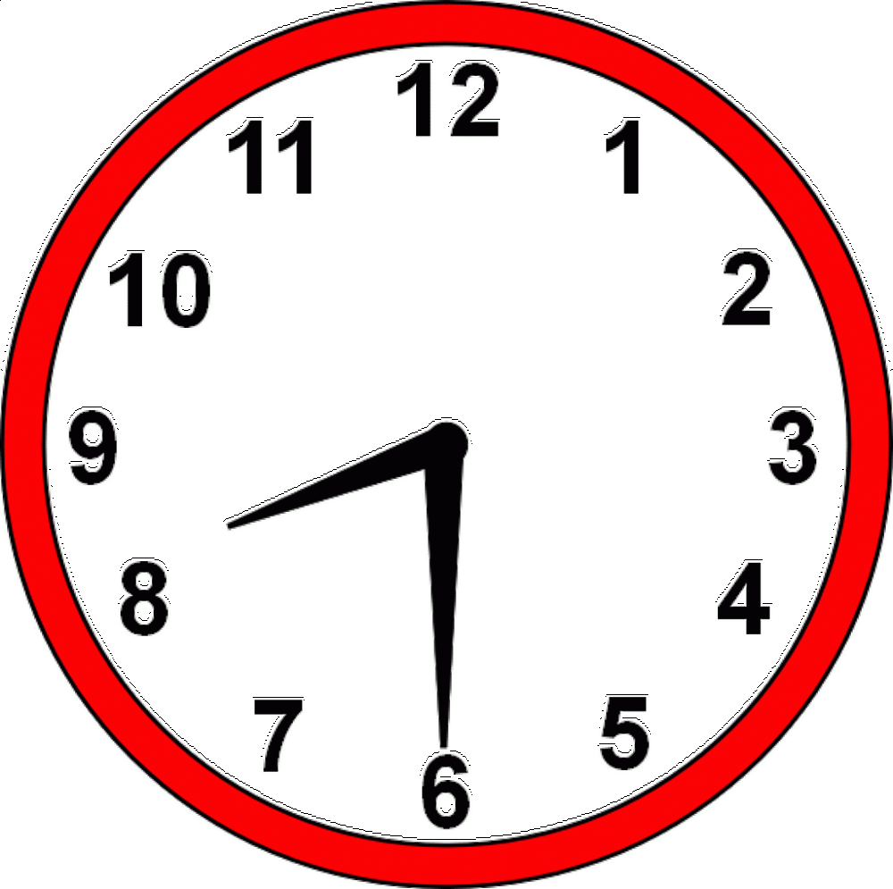 | Checklist:  Breakfast 🎟  Teeth Brushed 🎟  Learning area set up 🎟  Distractions away 🎟
9 o’clock | Login to register with your class  Live Maths
10 o’clock | Stretch! Drink! Toilet
11 o’clock | Live English
12 o’clock | Lunch break and a breath of fresh air!
1 o’clock | Live lesson
2 o’clock

3 o’clock

