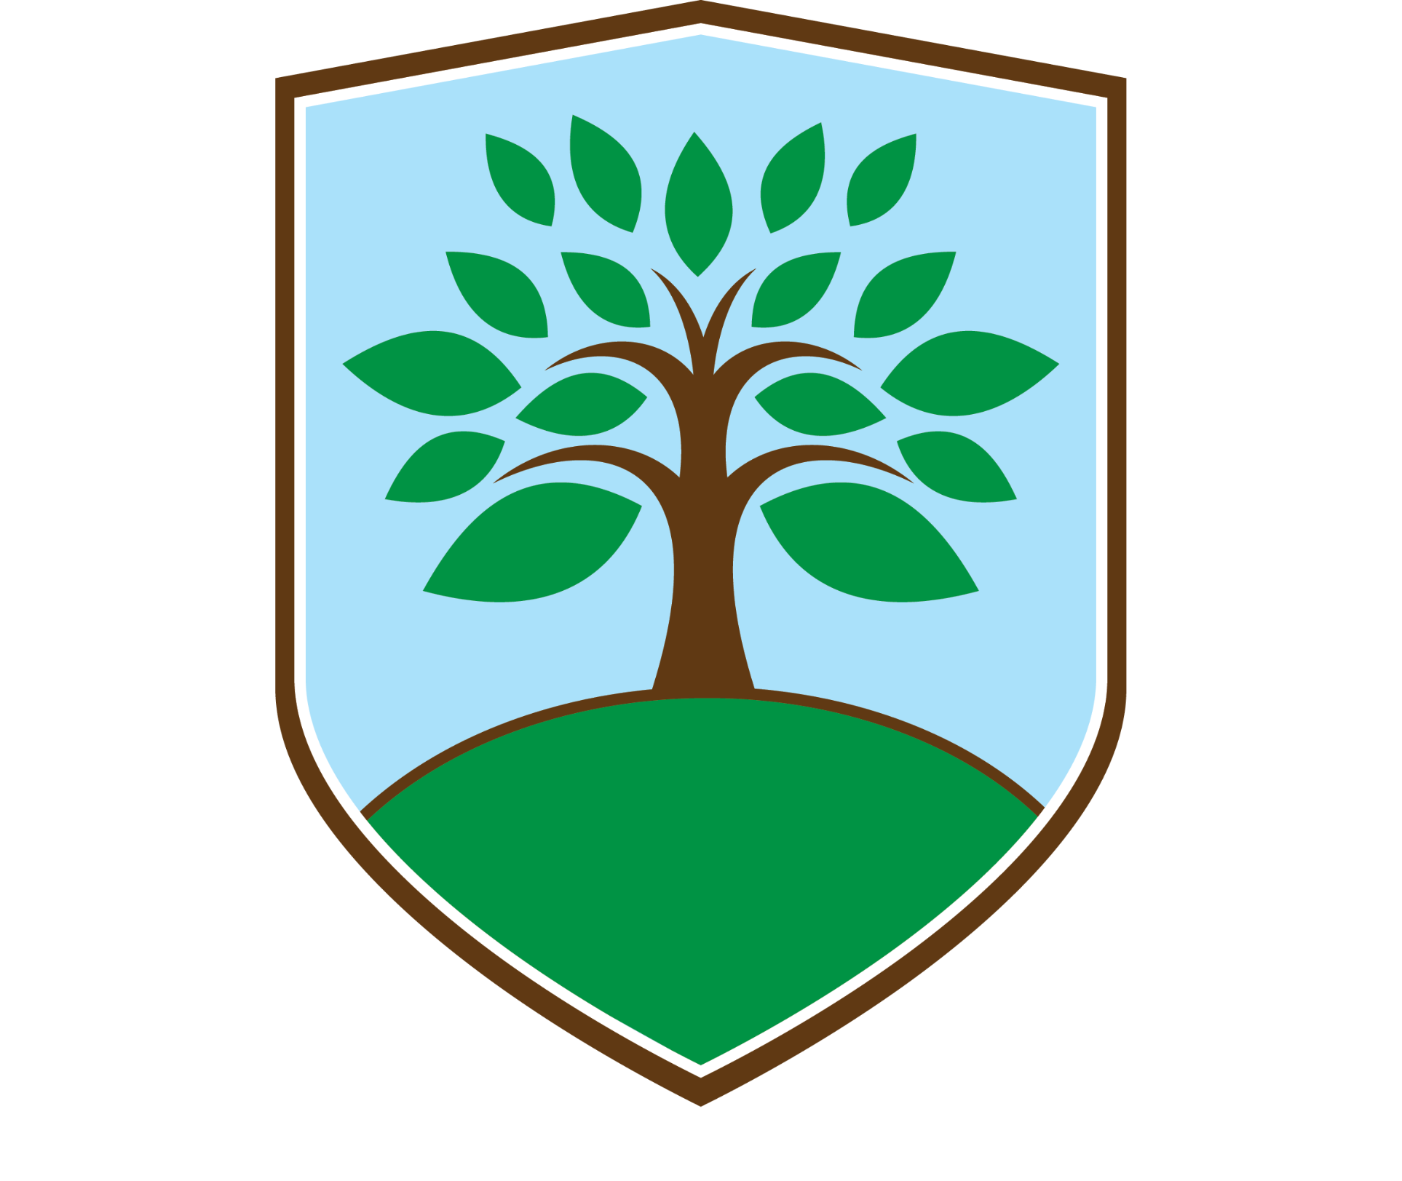  Geography | EYFS | Key Stage One |  | Key Stage Two
 |  | Year 1 | Year 2 | Year 3 | Year 4 | Year 5 | Year 6
Processes and Changes | Identify simple changes in the environment, giving reasons for these where possible | Know that places change over time and that there is often a range of evidence to show less |  | Know that's both primary and secondary sources of evidence show process and change |  | Understand the reasons for different processes and resulting changes in a range of locations
Human Geography | Know that human geographical features on man-made | Know some basic human geographical features in the focus area that describes them |  | Know, compare and describe some human geographical features in the wider world |  | recognise understand and explain patterns in human geography
Physical Geography | Know that physical geographical features are natural | Know some basic physical geographical features in the focus area and describe them |  | Know, compare and describe some physical geographical features in the wider world |  | Understand the physical geography of a place influences the lives of its inhabitants
Geographical vocabulary | Know and understand simple propositional and directional language | Know and understand simple vocabulary related to place |  | Know and understand key vocabulary related to geographical processes |  | Know and understand will technical vocabulary for example biome, climate zone
Locations and Environments | Know the names of places in their immediate locality and say what those places are like | Name and locate some key places in their own country and countries in the wider world |  | Know and understand the interrelationship between location and environment |  | Compare and contrast diverse locations and environments
Similarities and differences | Name some similarities and differences between places that are familiar to them | Identify basic similarities and differences between a range of locations and environments |  | Understand how and why some places and features are similar or different give reasons |  | Understand why different places employ different strategies for solving similar problems
Investigation |  | - Explore and discover the interesting features of a local environment  - Explore and Discover where different foods come from | - Ask and respond to geographical questions about people, places and environments  - Investigate, measure and record changes in the weather | - Ask and respond to questions to develop a sense of place  - Collect and record evidence and begin to offer explanations  - Investigate key aspects of human and physical geography  - Explore places with different climate zones | - Ask and respond to geographical questions and offer their own ideas  - Explore places with different climate zones and compare and describe how climate affects living things | - Ask suitable geographical questions leading to investigation  - Investigate ways in which environments can be improved  - Investigate using an increasing range of primary and secondary sources of information | - Ask questions, explore, describe and explain geographical patterns, similarities, differences  - Collect and record evidence independently  - Investigate ways in which environments can be managed sustainably and why is it important now and in the future
Observation |  | - Recognise and observe main human and physical features  - Recognise different types of weather and climate | - Recognise, observe, describe and record physical and human features  - Identify links between the locality and other places in the UK and beyond  - Discuss how weather affects our lives  - Locate features on globes commer maps and plans | - Identify where significant places are located in the UK, Europe and the wider world  - Identify similarities and differences between places and environments and understand how they are linked  - Identify how the ways in which people live sometimes have consequences for the environment | - Identify where significant places are located in the UK, Europe and the wider world  - Observe and appreciate the relationship between the physical, built and economic and social environments  - Identify how different ways in which people live around the world sometimes have consequences for the environment and the lives of others | - Analyse evidence and draw conclusions  - Identify a range of geographical processes that cause change in the physical and human world in different places | - Identify and explain different views that people, include themselves, hold about topical geographical issues  - Observe and explain how human patterns are influenced by both human and physical features
Application |  | - Express their own views about features of the environment  - Communicate in different ways using simple geographical information and vocabulary  - Use simple fieldwork skills  - Globes, maps and plans  - Make simple plans | - Make simple comparisons between features of different places and say how these features influence life there  - Use simple compass directions  - Communicate in different ways using appropriate geographical vocabulary locational and directional language  - Use fieldwork and observational skills to carry out simple tasks  - Use aerial photographs and plan perspectives to identify landmarks and features  - Make simple maps and plans | - Use appropriate geographical vocabulary to communicate their findings  - Collect and analyse a range of data from simple fieldwork experiences  - Classes, globes, maps and plans at a range of scales and draw simple maps and plans  - Use IT to help in geographical investigations | - Use appropriate geographical vocabulary in communicating findings  - Employ a wider range of fieldwork techniques and instruments to collect and analyse a range of data  - Describe, compare and offer reasons for their views  - Interpret information from different types of atlas, globes, maps and plans to range of scales  - Use secondary sources of information IT part of investigations | - Use appropriate geographical vocabulary to communicate in a variety of ways  - Use atlasses, globes, maps and digital mapping to range of scales  - Draw plans and maps at a variety of scales  - Use the eight points of a compass  - Use appropriate fieldwork techniques and instruments to observe, measure and record human and physical features in the local area | - Use and select primary and secondary sources of information and evidence, suggest conclusions and present findings in a variety of ways  - Use atlases, globes, maps and digital mapping at a range of scales, including four and six figure grid reference  - Draw plans and maps at a variety of scales  - Use symbols and keys when sketching maps, plans and graphs

