
Attendance Policy
2026/2027

Compiled/ Reviewed and Updated | Author:  Luke Alderton | Date:  September 2026
Approval By:  Charlotte Bull | Date:  September 2026 | Review Date:  September 2027

1. Aims
At The Laurels Primary School, excellent attendance is fundamental to children achieving, belonging and thriving. Every day in school provides opportunities for pupils to learn, develop relationships, build confidence and participate fully in the life of our school. Regular attendance is therefore both an educational priority and an important part of our safeguarding and inclusion responsibilities.

We recognise that improving attendance is a shared responsibility. We maintain high expectations for all pupils while recognising that the barriers affecting attendance are different for every child and family. Our approach is therefore rooted in strong relationships, early identification, effective support and partnership with families. Where barriers exist, we will seek to understand and remove them; where additional needs exist, we will make appropriate adjustments and coordinate support; and where support is unsuccessful or there is insufficient engagement, we will use formal intervention where appropriate.

Our attendance policy aims to:
- develop and sustain a whole-school culture in which excellent attendance is understood as everyone's responsibility and every pupil feels safe, valued and that they belong;
- secure high levels of attendance and punctuality so that pupils have the best possible opportunity to achieve academically, socially and personally;
- identify emerging absence and patterns of non-attendance at the earliest opportunity, rather than waiting for attendance to reach statutory thresholds;
- understand the individual causes of absence and work collaboratively with pupils, families and partner agencies to remove barriers to attendance;
- ensure that pupils who experience additional barriers, including those with SEND, medical or mental health needs, disadvantage or wider vulnerabilities, receive appropriate support and reasonable adjustments while maintaining ambitious expectations for their education;
- treat attendance as an integral part of safeguarding, recognising that absence from education may indicate additional need or increased vulnerability;
- use accurate and timely attendance information to identify patterns, disparities and emerging concerns at pupil, group and whole-school level;
- evaluate the impact of attendance strategies and interventions, adapting our approach where necessary so that attendance improves, particularly for pupils who are persistently or severely absent;
- celebrate improvement, commitment and positive attendance habits in ways that are inclusive and do not disadvantage pupils whose absence is outside their control;
- work in constructive partnership with parents and carers, ensuring expectations, responsibilities, available support and potential consequences are understood clearly; and
- fulfil all statutory responsibilities relating to school attendance while using legal intervention proportionately and appropriately when support has not secured improvement or when required by law.

Our ambition is not simply that pupils are present in school, but that every pupil is known, included and able to access a high-quality education consistently. Attendance improvement is therefore inseparable from the quality of our curriculum, relationships, safeguarding, SEND provision, pastoral support and the sense of belonging experienced by every child.
2. Legal and Statutory Framework
This policy has been developed in accordance with the Department for Education's statutory guidance, Working Together to Improve School Attendance (July 2026). The school, governing body and relevant partners will have regard to this guidance when carrying out their responsibilities for promoting and securing regular attendance.

The school recognises that regular attendance is both an educational entitlement and an important safeguarding and inclusion responsibility. Our attendance arrangements are therefore implemented alongside our duties to safeguard pupils, promote equality, support pupils with additional needs and ensure that every child of compulsory school age is able to access suitable education.

2.1 Relevant legislation
This policy reflects the requirements of relevant legislation, including:
- the Education Act 1996, including parents' legal responsibility to ensure that children of compulsory school age receive suitable full-time education and, where registered at a school, attend regularly;
- the Education Act 2002, including the school's duty to safeguard and promote the welfare of pupils;
- the Children Act 1989;
- the Children and Families Act 2014;
- the Education and Inspections Act 2006;
- the Equality Act 2010, including the school's duties in relation to disability, reasonable adjustments and discrimination;
- the School Attendance (Pupil Registration) (England) Regulations 2024;
- the Education (Penalty Notices) (England) Regulations 2007, as amended; and
- other legislation relevant to attendance, safeguarding and the provision of education.

2.2 Statutory and government guidance
This policy should be read alongside current Department for Education guidance, including:
- Working Together to Improve School Attendance;
- Children Missing Education;
- Keeping Children Safe in Education;
- Working Together to Safeguard Children;
- Special Educational Needs and Disability Code of Practice: 0 to 25 years;
- Supporting Pupils at School with Medical Conditions;
- Arranging Education for Children who Cannot Attend School Because of Health Needs;
- Alternative Provision: Statutory Guidance;
- Guidance relating to suspensions and permanent exclusions;
- Guidance on elective home education;
- Guidance on promoting and supporting mental health and wellbeing in schools and colleges;
- Guidance on preventing and tackling bullying; and
- Providing remote education: guidance for schools.

The school will ensure that this policy and its procedures are reviewed whenever relevant legislation or statutory guidance changes.

2.3 Core statutory expectations
In line with national statutory guidance, The Laurels Primary School will:
- develop and maintain a whole-school culture that promotes the benefits of high attendance;
- ensure that pupils, parents and staff understand attendance expectations and responsibilities;
- maintain accurate admission and attendance registers using the national attendance codes;
- operate effective day-to-day procedures to identify and follow up absence promptly;
- analyse attendance and absence information systematically to identify emerging patterns at pupil, group and whole-school level;
- intervene early and work in partnership with pupils and families to understand and remove barriers to attendance;
- provide appropriate support and reasonable adjustments for pupils who experience additional barriers to attendance, including pupils with SEND, physical or mental health needs or wider vulnerabilities;
- work collaboratively with the local authority, safeguarding partners and other agencies where absence is persistent, severe or indicative of wider need or risk;
- use formal and legal intervention appropriately where voluntary support has not been effective, has not been engaged with, or is not appropriate; and
- ensure that attendance practice supports, rather than undermines, pupils' right to education, safeguarding, inclusion and equality.

At The Laurels, statutory compliance represents the minimum expected standard. Our approach seeks to go further by identifying barriers early, evaluating the impact of support and ensuring that attendance improvement forms part of our wider work on safeguarding, inclusion, curriculum, wellbeing and belonging.

3. Roles and Responsibilities
3.1 The Governing Body
The Governing Body provides strategic oversight and challenge for attendance. Governors will:
- promote attendance as a whole-school priority and ensure that it forms part of the school's wider approach to safeguarding, inclusion, achievement and wellbeing;
- ensure that the school fulfils its statutory attendance responsibilities and that this policy is reviewed at least annually;
- ensure that a senior leader is designated to have overall responsibility for championing and improving attendance;
- scrutinise attendance information regularly, including whole-school attendance, persistent and severe absence, punctuality and attendance patterns within significant pupil groups;
- consider particularly the attendance of disadvantaged pupils, pupils with SEND, pupils known or previously known to children's social care, young carers and other pupils experiencing barriers to attendance;
- challenge leaders to explain significant trends, disparities and areas of concern and the action being taken in response;
- evaluate whether attendance strategies and interventions are having the intended impact, rather than considering activity alone;
- monitor the school's use of formal and legal interventions and seek assurance that support, reasonable adjustments and appropriate partnership working have been considered;
- ensure leaders have sufficient staffing, training, systems and resources to implement the school's attendance strategy effectively; and
- ensure that attendance information presented to governors enables them to provide effective challenge and hold leaders to account.

A named governor will maintain particular oversight of attendance and meet with the senior leader responsible for attendance as appropriate. The governor with oversight of attendance is [xx].

3.2 The Headteacher
The Headteacher retains overall accountability for the school's approach to attendance and will:
- ensure that attendance is prioritised as part of the school's wider work on safeguarding, inclusion, achievement and school improvement;
- ensure that a senior leader has sufficient authority, capacity and resources to lead attendance effectively;
- maintain appropriate oversight of significant attendance concerns and statutory responsibilities;
- support and challenge the Attendance Lead in securing improvement; and
- ensure that the Governing Body receives appropriate information about attendance priorities, patterns and impact.

3.3 Attendance Lead
The school’s Senior Attendance Champion is Luke Alderton, who is referred to throughout this policy as the Attendance Lead. He can be contacted via the school office at office@laurelsprimary.co.uk or 01903 830901.

The Attendance Lead leads the school's attendance strategy and will:
- lead the school's attendance strategy and champion a whole-school culture of high attendance, punctuality and belonging;
- oversee the implementation of this policy and ensure that attendance procedures are applied consistently, fairly and in accordance with statutory guidance;
- monitor and analyse attendance and punctuality at individual, group, cohort and whole-school level, identifying patterns, disparities and emerging concerns;
- maintain oversight of pupils who are persistently or severely absent, as well as those at risk of reaching these thresholds, ensuring that intervention begins at the earliest appropriate point;
- analyse the attendance of key pupil groups, including disadvantaged pupils, pupils with SEND, pupils known to children's social care, young carers and other pupils experiencing barriers to attendance;
- ensure that the reasons and barriers underlying absence are understood through effective communication with pupils, families and relevant professionals;
- oversee the school's graduated response to attendance concerns, ensuring that support is timely, proportionate and responsive to individual circumstances;
- ensure appropriate support, reasonable adjustments and reintegration strategies are considered for pupils experiencing additional barriers to attendance;
- lead complex attendance cases where appropriate and coordinate multi-agency support where barriers cannot be resolved by the school and family alone;
- oversee the attendance, safeguarding and educational access of pupils attending alternative provision or other off-site education;
- oversee any temporary part-time timetables, ensuring that they are exceptional, regularly reviewed and supported by a clear plan for return to full-time education;
- ensure that required attendance information and statutory returns are submitted accurately and within the required timescales;
- ensure that arrangements for sharing daily attendance data with the Department for Education are operating effectively;
- work collaboratively with the Local Authority and other relevant partners where attendance concerns require additional support, formalisation or legal intervention;
- ensure that formal and legal interventions are used appropriately and in accordance with statutory guidance;
- evaluate the impact of attendance interventions and wider school strategies, adapting or escalating approaches where they are not securing sufficient improvement;
- identify areas of effective practice and areas requiring improvement, using this analysis to inform school improvement priorities and staff development;
- ensure that staff understand their role in promoting attendance and provide guidance, support and challenge where required;
- maintain appropriate oversight of attendance records, processes and statutory requirements;
- report regularly to the Headteacher and Governing Body on attendance patterns, priorities, actions and impact; and
- keep the school's attendance practice under review in response to changes in legislation, statutory guidance, local priorities and emerging evidence of effective practice.

3.4 Attendance and Office Staff
Staff responsible for the day-to-day administration of attendance will:
- maintain accurate and timely attendance records;
- ensure appropriate national attendance codes are used;
- record and follow up reasons for absence;
- implement first-day absence procedures promptly;
- contact parents and emergency contacts where required;
- identify unexplained absence or concerning patterns and escalate these promptly;
- ensure changes to attendance registers are made in accordance with statutory requirements;
- communicate emerging concerns to the Attendance Lead or a Designated Safeguarding Lead if necessary;
- support the preparation of attendance information and analysis; and
- be an extra layer of vigilance in monitoring patterns of attendance and/or concerns.

3.5 School Staff
Staff will:
- promote the value of attendance through positive relationships and consistently high expectations;
- create safe, welcoming and inclusive environments in which pupils feel known, valued and that they belong;
- notice emerging patterns of absence, lateness or changes in a pupil's engagement and raise concerns promptly;
- listen carefully when pupils disclose barriers or worries affecting their attendance and respond in accordance with safeguarding procedures;
- avoid assumptions about the causes of absence and share relevant information with appropriate leaders;
- welcome pupils positively following absence and support successful reintegration without embarrassment or blame;
- implement agreed reasonable adjustments and attendance support strategies consistently;
- communicate positively and professionally with families about attendance; and
- recognise and celebrate improvements in attendance and engagement appropriately.

Class teachers have a particularly important role because their regular contact with pupils and families means they may identify emerging concerns before these are visible within headline attendance figures.

They also are responsible for recording attendance on a daily basis and submitting this information to the school office. At The Laurels, we use Arbor to register children and this should be completed in the morning at 8.40am. The afternoon register will be taken at 1:00pm for all pupils. Teachers must submit the register promptly at this time. Where exceptional circumstances prevent this, it must be completed as soon as possible and the school office informed.

3.6 Parents and Carers
Parents and carers are expected to:
- ensure their child attends every day the school is open unless a statutory reason for absence applies;
- ensure their child arrives at school punctually and ready to learn;
- notify the school by 8:30am on the day of the absence, or as soon as possible thereafter, and provide the reason for absence;
- maintain communication of when they are expected to return with school during continued absence by phone or messaging through the Arbor app;
- provide accurate and up-to-date contact information;
- arrange medical and dental appointments outside school hours wherever reasonably possible;
- request any leave of absence in advance and understand that leave will only be authorised where statutory criteria are met;
- share with the school, at the earliest opportunity, any barriers or changes in circumstances that may affect their child's attendance;
- engage with attendance meetings, support plans and agreed actions where concerns arise;
- work in partnership with the school and other services to improve their child's attendance where necessary; and
- provide, if requested, evidence relating to the absence e.g. evidence of appointment

3.7 Pupils
Pupils will be encouraged and supported to:
- attend school regularly and arrive punctually;
- understand why regular attendance is important;
- speak to a trusted adult if something is making it difficult for them to attend or feel safe and settled in school;
- identify strategies, relationships and adjustments that help them attend successfully; and
- recognise and celebrate their own improvements and successes.

3.8 Working with Other Agencies
Where barriers to attendance cannot be resolved by the school and family alone, the school will work collaboratively with relevant partners, which may include the Local Authority Dedicated Schools Team, health professionals, SEND services, children's social care, Early Help and other appropriate agencies.
Information will be shared lawfully and proportionately where this is necessary to safeguard a child, understand barriers or coordinate support.
Multi-agency involvement will have a clear purpose, identified actions and review arrangements. The school will evaluate whether external support is improving the pupil's ability to access education and will escalate concerns where sufficient improvement is not secured.

4. Recording Attendance and Absence
The Laurels Primary School will maintain accurate attendance records and apply the national attendance and absence codes in accordance with the School Attendance (Pupil Registration) (England) Regulations 2024 and current Department for Education guidance.

The school will share attendance information with the Department for Education and West Sussex County Council where required by law. Information will be shared securely and in accordance with data-protection and safeguarding requirements.

This will include:
- sharing daily attendance data through the school’s management information system;
- notifying the local authority when pupils are added to or removed from the admission register outside standard transition points;
- making attendance and sickness returns where statutory criteria are met; and
- providing attendance information requested by authorised bodies.

The appropriate code will be determined according to the individual circumstances of each absence and the evidence available to the school. Authorising an absence does not mean that the absence is without educational impact or that additional support is unnecessary. Where patterns of absence emerge, the school will seek to understand the reasons and consider appropriate support regardless of whether individual absences are authorised or unauthorised.

Where the circumstances of an absence are unclear, the school will work with the pupil and family to establish the reason and apply the appropriate national code.

4.1 Attendance Register and Session Times
The school will maintain an electronic attendance register using Arbor. Registers are legal records and will be taken at the beginning of both the morning and afternoon sessions. Each pupil will be recorded using the appropriate national code as:
- present;
- attending an approved educational activity;
- absent; or
- unable to attend due to an unavoidable cause.

Any amendment will retain the original and amended entries, the reason and date of the amendment, and the name and position of the person making it. Where applicable, the register will also record whether an absence is authorised and any further information required by the relevant code.

Every register entry will be retained securely for six years from the date it was made.

Pupils must arrive by 8:40am. The morning register will be taken at 8:40am and close at 9:10am. Arrival between these times will be recorded as late using Code L. Arrival after 9:10am will normally be recorded as an unauthorised absence using Code U, unless another national code is more appropriate due to the circumstances of the absence.
The afternoon register will be taken at 1:00pm or as close to the time as possible, but before 1:30pm. Patterns of lateness will be monitored, discussed with families and addressed through appropriate support or intervention.

4.2 Reporting Unplanned Absence
Parents and carers must notify the school of an unplanned absence by 8:30am on the first day, or as soon as reasonably possible, using the Arbor app or by contacting the school office. They should explain the reason for the absence and, where known, the expected date of return.

Absence due to physical or mental illness will normally be authorised. The school will not routinely request medical evidence. However, where illness is prolonged or recurrent, or the school has a genuine concern about the reason given, we may ask for appropriate supporting information and work with the family to understand whether further support is needed.

If the school is unable to establish a reason for an absence, or is not satisfied that it meets the criteria for authorised absence, it will be recorded as unauthorised. Parents and carers will be informed of this decision.

Where leave is taken without permission, or a pupil remains absent beyond the period of leave authorised by the school, the absence will be recorded as unauthorised. The school will consider whether further action is appropriate in accordance with the national framework and West Sussex procedures.

4.3 Planned Absence and Appointments
Parents should submit requests for leave of absence using the school's Leave of Absence Request Form, available from the school office or school website, before making arrangements wherever possible during term time. Each request will be considered individually and leave will only be authorised where the statutory criteria are met. Supporting information may be requested where this is reasonably necessary to enable the Headteacher to consider the circumstances.

Parents and carers should notify the school of medical or dental appointments as far in advance as reasonably possible, using the Arbor app or by contacting the school office. Evidence of the appointment may be requested. Where possible, appointments should be arranged outside school hours. If this is not possible, pupils should attend school before and after the appointment so that they miss the minimum amount of education necessary.

Leave of absence cannot be granted retrospectively. However, the school will apply the appropriate national code where information about an unplanned absence is established after the session.
See Section 5 for the circumstances in which term-time absence may be authorised.

4.4 Unauthorised Absence
Absence will be recorded as unauthorised where there is no statutory basis for authorising the absence, where leave has not been granted by the school, or where the school has not received a satisfactory explanation for the absence.

Examples may include:
- holidays or other leisure and recreational activities during term time;
- leave of absence that has not been requested or granted;
- absence extending beyond a period of authorised leave;
- shopping trips, day trips or birthdays;
- a pupil remaining at home without a reason that would meet the criteria for authorised absence;
- looking after siblings or accompanying family members to appointments;
- unexplained absence; and
- arrival after the register has closed, which is recorded as an unauthorised absence for that session.

The school will always consider the individual circumstances surrounding an absence and will seek to understand barriers before determining the appropriate attendance response.

Unauthorised absence will be monitored and may result in additional support, formal intervention or legal action where the relevant statutory criteria are met. Legal intervention will not replace the school's responsibility to understand and, where possible, address barriers to attendance.

4.5 Punctuality and Lateness
Punctual attendance is an important part of regular attendance. Arriving on time enables pupils to begin the day calmly, participate fully in initial learning and avoid disruption to their own education and that of others.

The school gates open at 8:30am and classroom doors open at 8:35am. Pupils are expected to be in their classrooms and ready to learn by 8:40am. The morning attendance register is taken at 8:40am and closes at 9:10am.

A pupil arriving after the register has been taken but before it has closed will be recorded as late using Code L. This is recorded as attendance for statistical purposes, but the lateness will still be monitored.

A pupil arriving after the register has closed will normally be recorded using Code U, meaning that they arrived after registration closed. This is recorded as an unauthorised absence for that session unless another national attendance or absence code more accurately reflects the circumstances.

Pupils arriving late must report to the school office with their parent or carer, where appropriate, so that:
- their arrival time and reason for lateness can be recorded accurately;
- the attendance register can be amended;
- the school knows that the pupil is safely on site; and
- the pupil can be supported to enter learning promptly and positively.

Parents and carers are expected to ensure that their child arrives punctually. Where unavoidable circumstances cause lateness, parents should inform the school as soon as possible.

The school will monitor the frequency, duration and patterns of lateness, including lateness before and after the register closes. Where a pattern emerges, the school will contact the family to understand the reasons, explain the educational impact and agree what support or action is required.

Responses to repeated lateness may include:
- an initial conversation with the pupil and parent or carer;
- communication from the school identifying the emerging pattern;
- support to understand and address practical or wider barriers;
- an attendance or punctuality meeting;
- an agreed punctuality improvement plan with clear actions and review dates;
- formal attendance intervention where concerns persist; and
- consideration of legal intervention where unauthorised absence meets the relevant statutory criteria.

Pupils arriving late will be welcomed into school calmly and without public embarrassment or blame. Supportive reintegration does not remove the school’s responsibility to record, monitor and address persistent lateness.

The school will consider the individual circumstances underlying lateness, including any SEND, medical, mental health, family or safeguarding factors. Appropriate support and reasonable adjustments will be considered where necessary. However, high expectations for punctuality will be maintained for all pupils.

Where repeated late arrival after the register has closed results in unauthorised absence, these sessions may contribute towards the relevant penalty-notice threshold. Any decision to issue a penalty notice rests with West Sussex County Council.

4.6 Following up Unexplained Absence
Where any pupil we expect to attend school does not attend, or stops attending, without reason, the school will:
- call the pupil’s parent/carer on the morning of the first day of unexplained absence to ascertain the reason. Where contact cannot be established, the school will assess the pupil’s vulnerability and known circumstances before proceeding with further action. This may include contacting emergency contacts, consulting the DSL, undertaking a risk-assessed home visit or contacting relevant agencies, including children’s social care or the police where there is an immediate welfare concern;
- identify whether the absence is approved or not;
- identify the correct attendance code to use and input it as soon as the reason for absence is ascertained – this will be no later than 5 school days after the session.
- Call the parent/carer on each day that the absence continues without explanation to ensure proper safeguarding action is taken where necessary. If absence continues, the school will consider involving Pupil Entitlement services from West Sussex County Council.

4.7 Attendance and Safeguarding
The Laurels Primary School recognises that absence from education can be an important safeguarding indicator. Patterns of absence, unexplained absence, sudden changes in attendance or failure to return to school when expected may indicate that a pupil requires additional support or is at increased risk of harm.

Attendance concerns will therefore be considered alongside the school's wider safeguarding information rather than in isolation. Where absence gives rise to a safeguarding concern, the school's safeguarding procedures will take precedence and information will be shared with appropriate agencies in accordance with statutory guidance.

Particular attention will be given to unexplained or changing patterns of absence for pupils who are known to be vulnerable, including pupils known to children's social care and those for whom the school has existing safeguarding concerns.

Attendance intervention and safeguarding action may take place simultaneously where appropriate.

4.8 Pupils Attending Education Off Site
Where a pupil attends alternative provision or another approved educational activity, the school will remain responsible for monitoring their attendance, safeguarding and access to education.

The school will agree arrangements with the provider for attendance information to be shared promptly.
Any unexpected or unexplained absence will be followed up in accordance with the school’s first-day response and safeguarding procedures.

Attendance will be recorded using the appropriate national code. Code B will only be used where the pupil is attending an approved, supervised and face-to-face educational activity.

4.9 Temporary Part-Time Timetables
All pupils of compulsory school age are entitled to full-time education. A temporary part-time timetable will only be used in exceptional circumstances where it is in the pupil’s best interests and has been agreed with the parent or carer.

The arrangement will:
- have a clearly defined purpose and intended outcome;
- specify the sessions the pupil is expected to attend;
- be reviewed regularly;
- include appropriate safeguarding and education arrangements; and
- contain a clear plan and timescale for returning to full-time education.

The appropriate national attendance codes will be used, and the local authority will be informed where required. A part-time timetable will not be used to manage behaviour or as an alternative to suspension.

4.10 Reporting to Parents/Carers
The school will regularly inform parents about their child’s attendance and absence levels via the Arbor app. An annual attendance percentage is recorded in the annual school report. Where an emerging pattern or concern is identified, the school will contact the family promptly rather than waiting for routine reporting points. Communication will explain the concern, invite the family’s views and identify any support or action required.

5. Authorised and unauthorised absence
The school will record absence using the national attendance codes and in accordance with the School
Attendance (Pupil Registration) (England) Regulations 2024. Whether an absence is authorised depends on the circumstances and the applicable national code; it is not determined solely by a parent’s explanation or request.

Authorising an absence does not mean that it has no educational impact. Where absence is prolonged, recurrent or forms a concerning pattern, the school will seek to understand the barriers and consider appropriate support regardless of whether the individual sessions are authorised or unauthorised.

5.1 Approval for term-time absence
The Headteacher, or a member of staff authorised by the Headteacher, may grant leave of absence where:
- an application has been made in advance by a parent/carer with whom the pupil normally lives; and
- the circumstances of the request are considered exceptional or another statutory basis for granting leave applies.

Requests should be submitted using the school’s Leave of Absence Request Form as soon as possible and, wherever practicable, at least five days before the proposed absence. The school may request appropriate supporting information where this is reasonably necessary to consider the application.

Each request will be considered individually, taking account of the specific facts, circumstances and relevant background context. Where leave is granted, the school will determine the number of school days for which the pupil may be absent.

A need or desire for a holiday or other leisure or recreational activity is not generally considered an exceptional circumstance and will not be authorised. Leave will not be granted for a pupil to take part in protest activity during school hours.

Leave of absence cannot be granted retrospectively. Where leave is taken without permission, or a pupil remains absent beyond an authorised period, the absence will be recorded as unauthorised.

5.2 Authorised Absence
Absence will be authorised where the circumstances meet the requirements of the relevant national attendance code. This may include:
- illness, including physical or mental illness;
- an approved medical or dental appointment;
- religious observance on a day exclusively set apart by the religious body to which the parent belongs;
- a mobile child travelling with a parent in the course of the parent’s trade or business;
- leave granted in advance for exceptional circumstances;
- participation in an approved performance or regulated employment; and
- other circumstances covered by the statutory attendance framework.

The school will consider the individual circumstances and evidence available when deciding which national code applies. Authorising an absence does not prevent the school from offering support where absence is prolonged, recurrent or affecting a pupil’s access to education.

5.3 Unauthorised Absence
Absence will be recorded as unauthorised where there is no statutory basis for authorising it, permission has not been granted or the school has not received a satisfactory explanation.

Examples may include:
- term-time holidays or other leisure and recreational activities;
- leave taken without prior permission;
- absence continuing beyond an authorised period;
- unexplained absence;
- absence where the reason provided does not meet the criteria for an authorised code;
- shopping trips, birthdays or family day trips;
- remaining at home to look after siblings or accompany family members to appointments; and
- arrival after the register has closed, unless another national code more accurately reflects the circumstances.

The school will consider the circumstances surrounding the absence and seek to understand any barriers before deciding what support, formalisation or legal action may be appropriate.

5.4 Attendance Support and Formal Intervention
Where attendance concerns emerge, the school will work with the pupil and family to understand the causes and provide appropriate support. This may include an attendance meeting, an attendance support plan, reasonable adjustments, reintegration support or involvement from relevant professionals and services.
Where voluntary support has not secured sufficient improvement, the school may formalise the arrangements through a written attendance contract or other appropriate plan.

This will identify:
- the attendance concern and barriers identified;
- the support being provided;
- the actions expected from the school, family and other services;
- the intended improvement;
- clear review dates; and
- the possible consequences if attendance does not improve.

Where support is unsuccessful, is not engaged with or is not appropriate, the school may seek formal or legal intervention from West Sussex County Council. Legal intervention will be considered proportionately and will not replace the school’s responsibility to understand and, where possible, address barriers to attendance.

5.5 Penalty Notices
The national framework requires schools to consider whether a penalty notice is appropriate when a pupil accumulates 10 sessions of unauthorised absence, equivalent to 5 school days, within a rolling period of 10 school weeks.
The sessions:
- may be consecutive or non-consecutive;
- may span different terms or school years; and
- may include a combination of unauthorised absence codes, such as unauthorised leave, other unauthorised absence and arrival after the register has closed.

West Sussex eight-session referral criterion
West Sussex County Council may also consider issuing a penalty notice where a pupil has accumulated eight sessions of unauthorised absence, equivalent to four school days, in circumstances suggesting that the absence has been arranged to avoid the national 10-session threshold.

This applies particularly where four days of unauthorised absence are taken:
- during a week containing a school INSET day;
- immediately before or after a bank holiday; or
- in another comparable pattern that appears designed to prevent the absence from reaching five school days or 10 sessions.

In these circumstances, the school will consider making a referral to the West Sussex Pupil Entitlement: Investigation Team even though the national 10-session threshold has not been reached. West Sussex County Council will consider the individual circumstances and decide whether a penalty notice should be issued in accordance with its Code of Conduct.

Where support is appropriate, the school and local authority will consider whether sufficient support has been offered and whether a Notice to Improve should be issued before a penalty notice. A Notice to Improve may not be appropriate where support would not be relevant, such as some unauthorised term-time holidays.

Where a penalty notice is considered appropriate, it may be issued to each person with parental responsibility, as defined by section 576 of the Education Act 1996, in respect of each child. The decision to issue a penalty notice rests with West Sussex County Council.
The national arrangements are:
- First penalty notice: £160 for each parent, for each child, reduced to £80 if paid within 21 days.
- Second penalty notice: where issued to the same parent for the same child within three years of the first notice, £160 payable within 28 days, with no reduced rate.
- Third or subsequent occasion: a third penalty notice cannot be issued to the same parent for the same child within three years of the first notice. Where the national threshold is met again, an alternative legal intervention will be considered, which may include prosecution.

If a penalty notice is not paid within 28 days, West Sussex County Council may prosecute the parent for the original attendance offence or withdraw the notice in accordance with the applicable legal framework.
6. Strategies for Promoting Attendance and Belonging
The Laurels Primary School will promote attendance through a whole-school culture in which pupils feel safe, known, included and motivated to attend. High expectations will be combined with positive relationships, early support and a consistent focus on belonging.
We will:
- ensure pupils are welcomed positively each day and following any period of absence;
- provide a safe, inclusive and engaging curriculum that gives pupils meaningful reasons to attend;
- ensure staff understand their role in noticing and responding to emerging barriers;
- listen to pupils and families and use their views to improve attendance support;
- communicate attendance expectations clearly, sensitively and consistently;
- share appropriate guidance, including NHS advice, to help families make informed decisions about illness;
- provide additional support during periods of transition, reintegration or increased vulnerability;
- recognise patterns or circumstances that may make particular days or periods more difficult and respond proactively;
- evaluate whether attendance initiatives are improving attendance, punctuality and pupils’ sense of belonging; and
- provide additional professional development for staff to support attendance and punctuality.

6.1 Recognising and Celebrating Attendance
Attendance and punctuality will be recognised positively through assemblies, newsletters, certificates, Arbor communications and other appropriate celebrations.

Recognition may include:
- celebrating strong class attendance and punctuality in celebration assembly;
- rewarding class attendance and class punctuality with extra breaktime and, from time to time, other rewards as may be deemed appropriate;
- recognising individual and class improvement;
- thanking families for their support;
- celebrating commitment, resilience and positive attendance habits; and
- sharing attendance successes with the wider school community.

Celebration will be inclusive and sensitive to individual circumstances. Pupils will not be blamed, embarrassed or disadvantaged where absence results from circumstances outside their control. Rewards will therefore recognise improvement and commitment as well as high attendance, and will be reviewed to ensure they have a positive impact.

7. Attendance monitoring
The school will use accurate and timely attendance information to identify concerns early, understand their causes and evaluate whether support is improving pupils’ access to education.

7.1 Monitoring attendance
Attendance will be monitored:
- daily to identify absence requiring immediate follow-up or safeguarding action;
- weekly to identify emerging patterns of absence and lateness;
- half-termly and termly to evaluate individual, group and whole-school trends; and
- over time to assess sustained improvement and the impact of school actions.

Monitoring will include overall attendance, authorised and unauthorised absence, punctuality, persistent and severe absence, patterns across particular days or sessions and the reasons recorded for absence.

The school will share attendance information with the Department for Education and West Sussex County Council where required and will use national, local and similar-school information to support evaluation.

The school will compare attendance data to the national average, and share this with the governing board.

Attendance data will be benchmarked against relevant national, local and historic school data where available, so that leaders can identify significant trends, disparities and areas requiring further investigation or action.

7.2 Monitoring Access to Education
The school will monitor the attendance and educational access of all pupils, including those attending alternative provision, receiving education off site, subject to a temporary part-time timetable or receiving education arranged by the local authority under section 19 of the Education Act 1996.

Where a pupil requires a temporary part-time timetable, alternative provision or off-site education, the school will ensure that the arrangement supports inclusion, safeguarding and a return to consistent access to education. The procedures in Sections 4.8 and 4.9 will apply.

Remote education will not be used as a routine alternative to attendance at school. Where it is considered for a pupil who is unable to attend, it will only be used as a last resort, in accordance with DfE guidance, and as part of a clear plan to support the pupil's reintegration into full-time education.

Attendance information will be obtained promptly from providers and any unexplained absence will be followed up through the school’s attendance and safeguarding procedures. Monitoring will also identify pupils whose overall attendance may appear satisfactory but who show emerging patterns of occasional absence or lateness. Where concerns arise, the school will act early to understand the barriers, coordinate support and review whether the pupil is accessing suitable education consistently.

7.3 Analysing attendance
The Attendance Lead will analyse attendance at individual, class, year-group and whole-school level.

Analysis will consider the attendance of significant pupil groups, including:
- disadvantaged pupils;
- pupils with SEND;
- pupils with medical or mental health needs;
- pupils known or previously known to children’s social care;
- young carers; and
- other pupils experiencing additional barriers or vulnerabilities.

School information will be compared with local, national and similar-school data where appropriate. Leaders will examine differences between groups and seek to understand the causes rather than drawing conclusions from percentages alone.

Findings will inform school improvement priorities, staff development, allocation of support and reports to the Headteacher and Governing Body.

7.4 Early Identification and Graduated Support
Intervention will not depend solely on a pupil reaching a particular attendance percentage. The school will respond to emerging patterns, changes in attendance, repeated lateness and known vulnerabilities at the earliest appropriate point.

Depending on need, the school’s graduated response may include:
- an initial conversation with the pupil and family;
- communication identifying the concern and offering support;
- discussion with the class teacher or another trusted adult;
- an attendance meeting to understand barriers;
- an agreed attendance support plan with actions and review dates;
- reasonable adjustments or reintegration support;
- involvement of the SENDCo, DSL, pastoral staff or external agencies;
- formalisation of support where voluntary arrangements have not secured improvement; and
- legal intervention where support is unsuccessful, is not engaged with or is not appropriate.

Support will be reviewed regularly and adapted or escalated according to its impact.

7.5 Reducing persistent and severe absence
A pupil is persistently absent when they miss 10% or more of possible school sessions and severely absent when they miss 50% or more.

The school will maintain close oversight of pupils who meet, or are at risk of meeting, these thresholds. For each pupil, leaders will seek to:
- understand the causes and interaction of barriers;
- hear the pupil’s and family’s views;
- coordinate appropriate educational, pastoral, SEND, medical or multi-agency support;
- establish clear actions, responsibilities and review points;
- safeguard the pupil and maintain appropriate contact during absence;
- support successful reintegration and recovery of missed learning; and
- evaluate whether the support is securing sustained improvement.

Severe absence will be treated as a priority. The school will work with West Sussex County Council and relevant agencies to agree a joint approach where the barriers are complex or school-led support is insufficient.

7.6 Evaluating Impact
The Attendance Lead will evaluate not only what action has been taken, but whether it has improved attendance, punctuality, engagement and access to education.

Evaluation will consider:
- changes in individual and group attendance;
- whether disparities are narrowing;
- progress among persistently and severely absent pupils;
- pupil and parent feedback;
- the effectiveness of support and reasonable adjustments;
- whether improvements are sustained; and
- any unintended effects of attendance strategies or rewards.

Where an approach is not having sufficient impact, it will be adapted, intensified or replaced. Attendance priorities, actions and impact will be reported regularly to the Headteacher and Governing Body.

8. Monitoring and Reviewing the Policy
The Attendance Lead will monitor the implementation and effectiveness of this policy throughout the year.

This will include considering:
- attendance and punctuality patterns and disparities between pupil groups;
- outcomes for pupils who are persistently or severely absent;
- the consistency and timeliness of school procedures;
- the impact of support, reasonable adjustments and formal intervention;
- feedback from pupils, families, staff and relevant partners;
- compliance with statutory responsibilities; and
- any unintended consequences arising from the school’s attendance practices.

Findings will be used to strengthen procedures, address inconsistencies and inform the school’s wider attendance strategy and improvement priorities.

The policy will be reviewed at least annually, and sooner where legislation, statutory guidance, local procedures or the needs of the school change. The Attendance Lead will lead the review, with appropriate oversight from the Headteacher.

The Governing Body will approve the policy and receive assurance that it is being implemented effectively. The current policy will be published on the school website and communicated clearly to pupils, families and staff.

9. Links with Other Policies
Attendance is closely connected to safeguarding, inclusion, SEND, health, behaviour and pupils’ access to education. This policy should therefore be read alongside the school’s current:
- Safeguarding and Child Protection Policy;
- Children Missing Education procedures;
- SEND Policy and SEND Information Report;
- Supporting Pupils with Medical Conditions Policy;
- Behaviour Policy;
- Mental Health and Wellbeing provision;
- Suspension and Permanent Exclusion Policy;
- Alternative Provision procedures;
- Admissions Policy;
- Equality Policy and Accessibility Plan;
- Data Protection Policy; and
- Remote Education arrangements, where applicable.

Where a pupil’s absence raises a concern about their safety or welfare, safeguarding and child-protection procedures will take precedence. Relevant policies will be applied together so that attendance concerns are not considered separately from a pupil’s educational, pastoral, medical or safeguarding needs.

Appendix 1
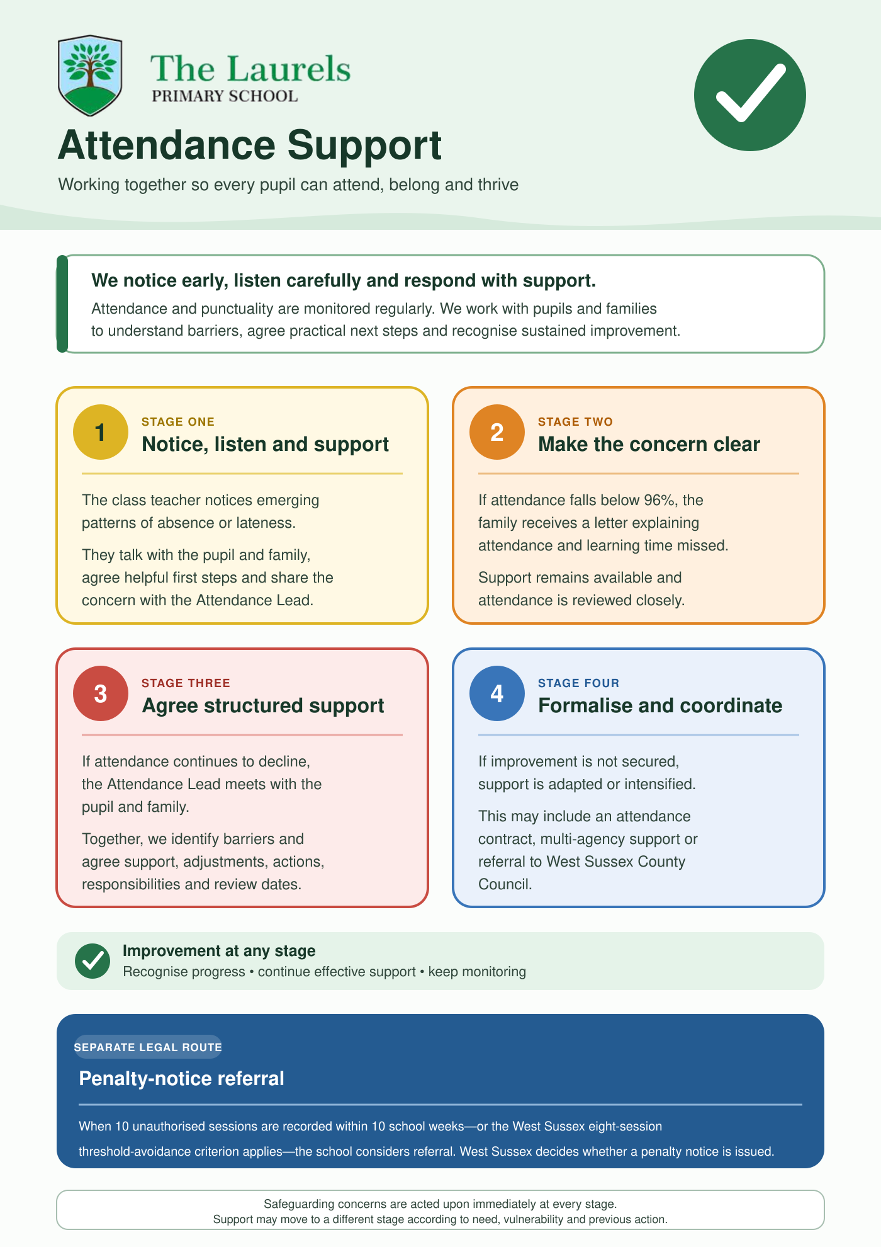
Appendix 2:
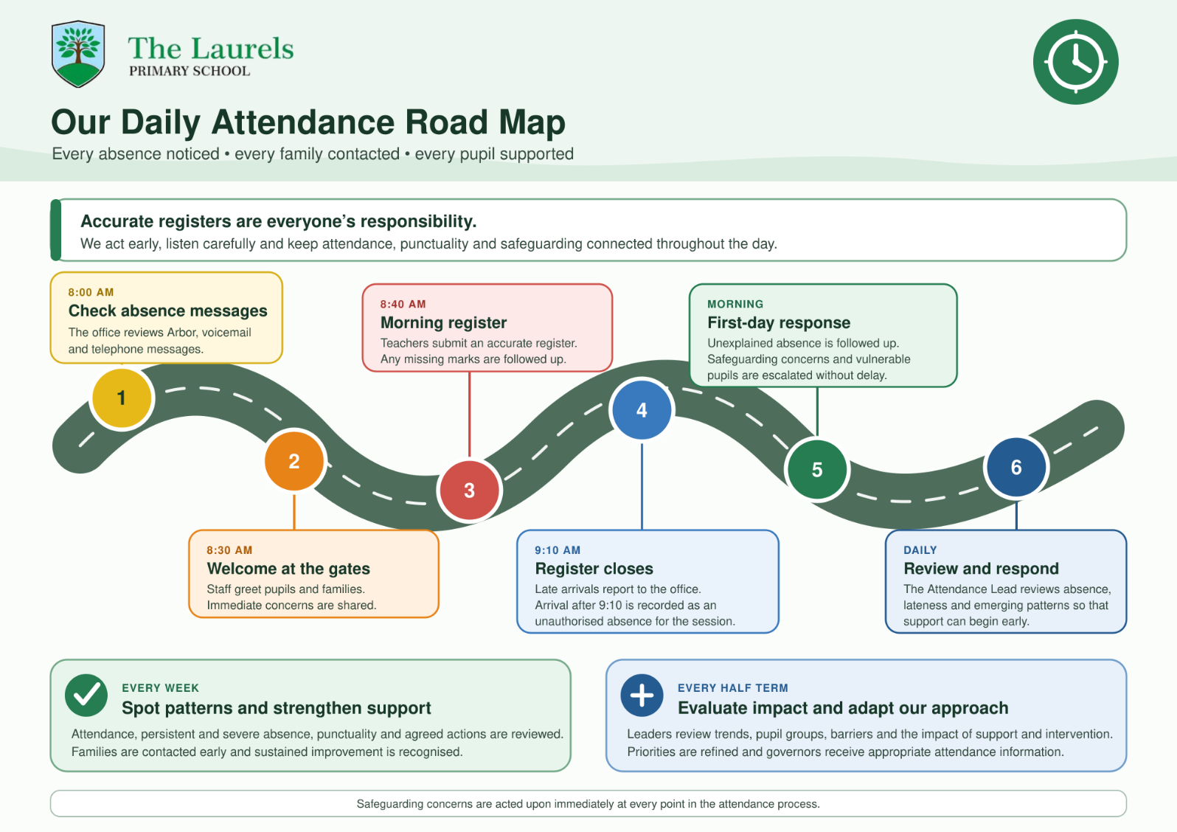

Appendix 3:
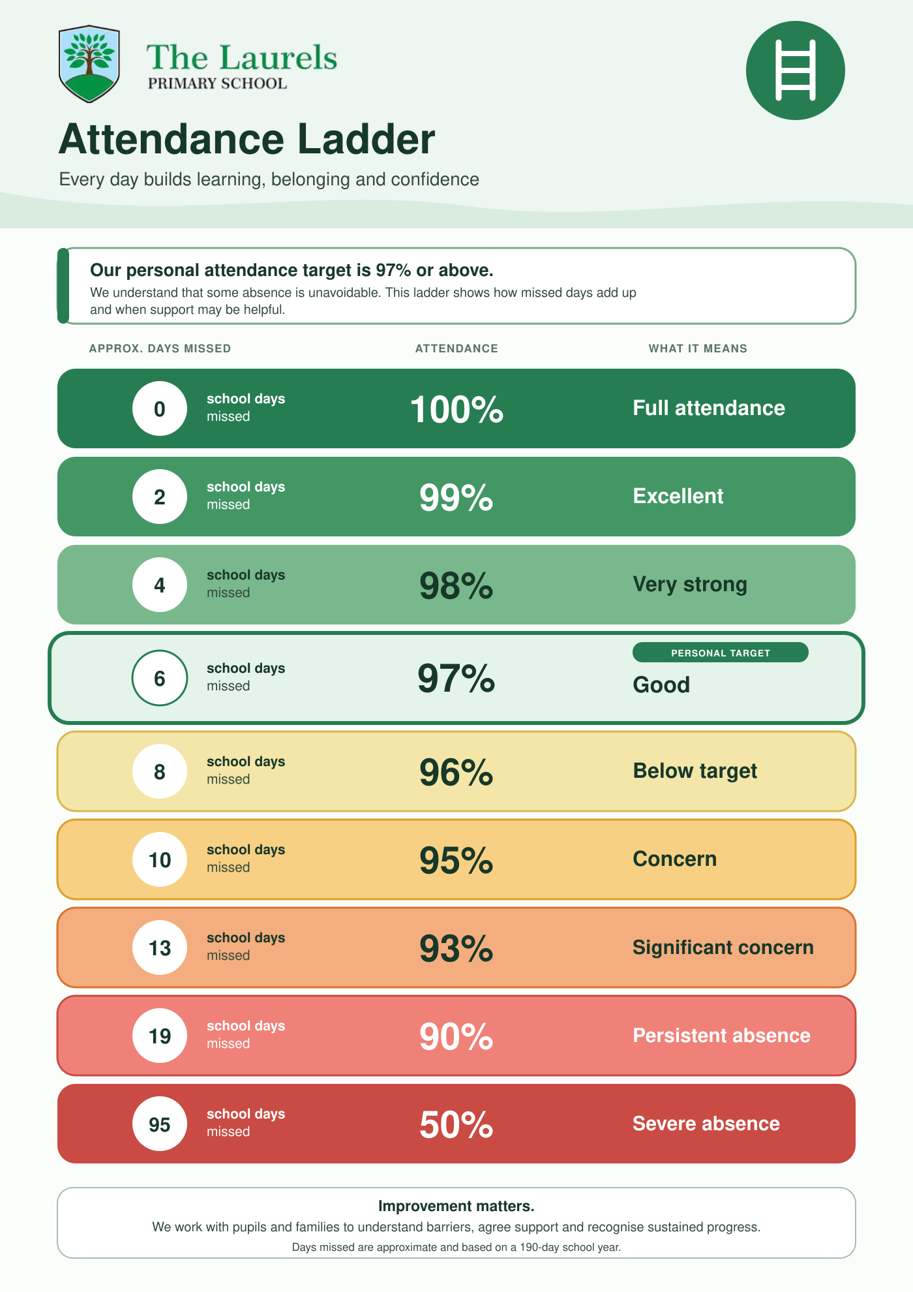

Appendix 4
