

SEND Information Report
2026-2027

- Aims
The Children and Families Act 2014 requires schools to publish a Special Educational Needs (SEN) Information Report. This report explains how The Laurels implements its SEND policy and meets the needs of pupils with SEND. This report is published on our school website and forms part of the West Sussex Local Offer www.westussex.gov.uk
In the report, we aim to:
- Explain how we support and make provision for pupils with special educational needs and disabilities.
- Explain the roles and responsibilities of everyone involved in providing for pupils with SEND

This report will be reviewed annually by staff and governors and the process will also involve pupils and parents. If you would like a copy of the report, please contact the school office.

Please refer to our SEND policy for more information about our school mission, values, vision and aims for inclusion at The Laurels.

2. Legislation and Guidance
This policy and information report is based on the statutory Special Educational Needs and Disability (SEND) Code of Practice and the following legislation:
- Part 3 of the Children and Families Act 2014, which sets out schools’ responsibilities for pupils with SEND and disabilities
- The Special Educational Needs and Disability Regulations 2014, which set out schools’ responsibilities for education, health and care (EHC) plans, SEND co-ordinators (SENDCos) and the SEND information report
This policy also complies with our funding agreement and articles of association.

3. Definitions
A pupil has SEND if they have a learning difficulty or disability that calls for special educational provision to be made for them.
They have a learning difficulty or disability if they have:
- A significantly greater difficulty in learning than the majority of the others of the same age, or
- A disability which prevents or hinders them from making use of facilities of a kind generally provided for others of the same age in mainstream schools
Special educational provision is educational or training provision that is additional to, or different from, that made generally for other children or young people of the same age by mainstream schools.

4. Roles and responsibilities

The SENDCo
The SENDCo is Amy Elsden aelsden@laurelsprimary.co.uk 01903 830901
They will:
- Work with the headteacher and SEND governor to determine the strategic development of the SEND policy and provision in the school
- Have day-to-day responsibility for the operation of this SEND policy and the coordination of specific provision made to support individual pupils with SEND , including those who have EHC plans
- Provide professional guidance to colleagues and work with staff, parents, and other agencies to ensure that pupils with SEND receive appropriate support and high-quality teaching
- Advise on the ‘graduated approach’ to providing SEND support
- Advise on the deployment of the school’s delegated budget and other resources to meet pupils’ needs effectively
- Be the point of contact for external agencies, especially the local authority (LA) and its support services
- Liaise with potential next providers of education to ensure that the school meets its responsibilities under the Equality Act 2010 with regard to reasonable adjustments and access arrangements
- Support children with transitions to new settings
- Ensure the school keeps the records of all pupils with SEND up-to-date

The SEND governor
The SEND governor is Sarah Gawman - sgawman@laurelsprimary.co.uk
They will:
- Help to raise awareness of SEND issues at governing board meetings
- Monitor the quality and effectiveness of SEND and disability provision within the school and update the governing board on this
- Work with the headteacher and SENDCo to determine the strategic development of the SEND policy and provision in the school

The headteacher
The headteacher is Charlotte Bull - office@laurelsprimary.co.uk 01903 830901
They will:
- Work with the SENDCo and SEND governor to determine the strategic development of the SEND policy and provision within the school
- Have overall responsibility for the provision and progress of learners with SEND and/or a disability

Class teachers
Each class teacher is responsible for:
- The progress and development of every pupil in their class
- Working closely with any teaching assistants or specialist staff to plan and assess the impact of support and interventions, and how they can be linked to classroom teaching
- Working with the SENDCo to review each pupil’s progress and development, and decide on any changes to provision
- Developing their knowledge and skills in relation to specific SEND needs represented in their class cohorts
- Writing individual learning plans
- Meeting with parents termly to discuss progress and needs
- Ensuring they follow the SEND policy

5. The kinds of SEND we provide for
The SEND register is reviewed regularly. Pupils may be added to or removed from the register as their needs and the provision they require change over time.
Within school, we use three levels to help us describe and review the provision pupils receive. These are not statutory categories of SEND but help us ensure that support is matched to need:
Intensive support - children who need specific adaptations and provisions which are not ordinarily available to the other children in the school. This would include children with EHCPs.
Targeted support - children who have identified SEND needs but who are making progress with the ordinarily available Inclusive Practice https://schools.westsussex.gov.uk/Article/169309
Monitoring - children who are receiving interventions and for whom we are initiating the first stages of the graduated approach. https://westsussex.local-offer.org/information_pages/672-graduated-send-support
Our school currently provides additional and/or different provision for a range of needs, including the 4 areas of SEND identified in the Code of Practice:

Area
Cognition and Learning e.g. dyslexia, dyspraxia, dyscalculia
Social, Emotional and Mental Health e.g. attention deficit hyperactivity disorder (ADHD), trauma
Sensory and Physical e.g. visual impairments, hearing impairments, processing difficulties
Communication and Interaction e.g. autistic spectrum disorder, speech and language difficulties

Please note some children have needs in multiple areas but a primary area of need will be identified.

6. How do we identify pupils with SEND?
We aim to identify children’s special educational needs or disabilities (SEND) as early as possible, so that the child achieves the best possible outcomes.
A pupil has SEND where their learning difficulty or disability calls for special educational provision. That is provision which is different from, or additional to, that normally available to pupils of the same age.
Children may also have a diagnosis of a special educational need from an external partner such as a diagnosis of Autism Spectrum Condition from the NHS.
This does not mean that they will automatically be placed on the SEND register. This will be determined by the level of support needed by the individual pupil.
We will assess each pupil’s current skills and levels of attainment on entry, which will build on previous settings and Key Stages, where appropriate. The Reception teacher, and SENDCo when appropriate, has in-depth meetings with all the nurseries/pre-schools for children who are joining the school; detailed assessments are exchanged and any needs identified. If a pupil has a disability under the Equality Act 2010 we make reasonable adjustments.
Class teachers will make regular assessments of progress for all pupils and identify those whose progress:
- Is significantly slower than that of their peers starting from the same baseline
- Does not match or better the child’s previous rate of progress
- Does not close the attainment gap between the child and their peers
- Widens the attainment gap
- This may include progress in areas other than attainment, for example, social needs.
This may include standardised testing, reading tests or targeted assessments carried out with pupils suspected to have additional needs. However, slow progress and low attainment will not automatically mean a pupil is recorded as having SEND.
Termly pupil progress meetings with the Assistant headteacher for curriculum, class teacher, support staff and SENDCo ensure that everyone has the opportunity to discuss any concerns they have about particular pupils and decide what may be the best provision to put in place.
When deciding whether special educational provision is required, we will start with the desired outcomes, including the expected progress and attainment, and the views and the wishes of the pupil and their parents. We will use this to determine the support that is needed and whether we can provide it by adapting our core offer, or whether something different or additional is needed.
From this, individual target setting sheets, provision maps, pupil passports and individual learning plans are put together that highlight individual/group interventions needed. Targets are specific, measurable, achievable, relevant and time-bound (SMART), enabling staff to evaluate pupils' progress and the impact of additional provision.
Pupils who do not make expected progress through the graduated approach may be further assessed by external agencies such as CAMHS, Speech and Language Services, the CDC.

7. How do we meet the needs of children with SEND?
At The Laurels we have an inclusive curriculum that enables every pupil to succeed and enjoy learning, whatever their abilities or needs. We provide a supportive environment where children feel valued and included.
Our starting point is high-quality, inclusive teaching and ordinarily available inclusive provision for all pupils. A pupil does not need to be on the SEND register to receive adaptations or additional support. Where this provision does not sufficiently meet a pupil's needs, we use the graduated approach to assess need, plan additional or different provision, implement it and review its impact.

Adaptations to the learning environment
- We ensure that the classroom environment takes into account cognitive load (the amount of working memory resources that a child is using at any one time). This means that our rooms are uncluttered and purposeful, without unnecessary sensory stimulation or extraneous content.
- Displays are considered to ensure that children can easily retrieve the relevant information and use them as tools for learning e.g. working walls and visual aids
- The positioning of the children is considered to ensure distractions are minimised and children can attend to the teaching.
- Recommended aids to support teaching and learning are available. These might include pen grips, sensory resources, mathematical equipment, use of larger fonts.
- Visual timetables are displayed in all classrooms
- The school will make reasonable adjustments and secure appropriate equipment from its delegated resources where possible. If a child requires specialist equipment or adaptations, the SENDCo will work with parents and seek advice and support from the local authority to gain these.

Teaching and Learning
Learning is carefully planned and sequenced to ensure that children have opportunities to learn more and remember more. Lessons begin with retrieval practice and children are provided with opportunities throughout the sequence of teaching to review their learning and self-assess. Live marking and feedback to pupils allows teachers to address misconceptions and provide intervention where necessary. This might mean adjusting the lesson, or providing an intervention outside of the lesson (Precision Teaching for example).
Children with SEND remain the responsibility of their class teacher and learn alongside their peers. Additional provision may take place individually or in a small group where this is identified as the most effective way of meeting a pupil's needs.
Here are some ways teachers might make adaptations for children with SEND:

- Providing visual prompts
- Pre-teaching vocabulary
- Providing task planners setting out the steps needed to complete the task
- Adapting the task to meet individual needs, for example, planning with pictures rather than words
- Providing additional opportunities for fluency practice
- Writing frames
- Providing sensory breaks or other sensory adaptations
- Providing reading pens

Additional provision is matched to an individual pupil's assessed needs and intended outcomes; there is not a set intervention for a particular diagnosis or area of SEND. Examples of provision currently available include:

Communication and Interaction
- Nurture Group
- Lego Therapy
- BLANKS level Questioning
- Calm Cafe
- SaLT input
- Listening and Understanding

Sensory and Physical
- Sensory Circuits
- Handwriting groups
- Fine-motor skills groups

Cognition and Learning
- Keep-up groups for maths and phonics
- Precision teaching
- Individual reading
- Numberstacks

Social, Emotional and Mental Health
- Nurture Group
- Calm Cafe
- Therapeutic services (Change Grow Live, ThoughtFULL evidence-based interventions, play therapy)

8. Expertise and training of Staff
Our staff have been trained using the EEF best practice guidance for children with Special Educational Needs in Mainstream settings. More information can be found here: https://educationendowmentfoundation.org.uk/education-evidence/guidance-reports/send This ensures that all children receive high-quality inclusive teaching using the best available research and resources.

They have also received training in the following areas:
- NASENCo Award
- Speech and Language Training
- Robust Vocabulary
- Social Communication
- Senior Mental Health Lead
- Mental Health First Aid
- Little Wandle Phonics
- Jump Ahead
- Precision Teaching
- Dyslexia & Dyscalculia
- ASD and ADHD
- Pathological Demand Avoidance
- Numberstacks
- Social and Emotional Development of children
- Supporting children with anxiety
- Trauma informed practice
- Drawing and Talking
- Zones of Regulation
- Emotion Coaching
- ACE’s – Adverse Childhood Experiences
- Lego Therapy
- Safeguarding
- Team Teach Training
- Bespoke medical training in response to individual needs. E.g. Diabetic, use of Epi-pens
- Many of our teaching assistants have NVQ Level 3 and the following Diploma in Supporting Teaching and Learning.
- Widgit software

When a pupil joins us who requires expertise beyond that available within school, the SENDCo will seek advice and support from the appropriate specialist service. This may include local authority advisory services, Educational Psychology, Speech and Language Therapy, health services and other specialist professionals. Recommendations from specialist professionals are incorporated into the pupil's provision and reviewed through the graduated approach. If needs change, the SENDCo will once again seek advice and support from the appropriate specialist service.

9. Assessing and reviewing pupils’ progress towards outcomes

The Graduated Approach
We follow the graduated approach and the four-part cycle of assess, plan, do, review.
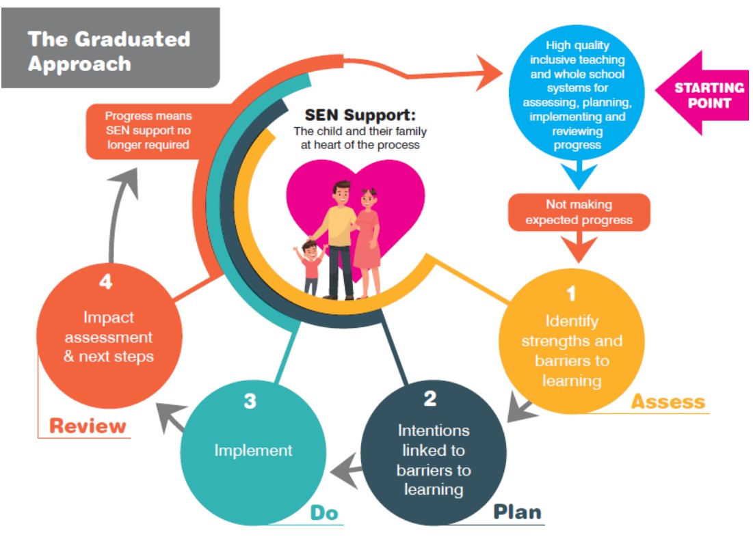

Assess
- Evidence is gathered from the class teacher, SENDCo, pupil and parents to identify specific needs. Pupil passports are created to represent the views of families and children. Pupil passports capture the pupil's strengths, what is important to them, the barriers they experience and the strategies that help them learn successfully. They are informed by pupils and families and shared with the adults who work with the child.

Plan
- Through discussion, the best provision and support is decided. Targets are set out on an Individual Learning Plan. These are reviewed a minimum of three times a year.
- A Provision Map is drawn up to show how the provision will be delivered.

Do
- The class teacher will implement the provision and provide support to meet the targets through high-quality, inclusive teaching, with appropriate adaptations to teaching, resources and the learning environment. Depending on the provision, some pupils will receive interventions, extra resources, small group focused activities or support from outside agencies.

Review
- Targets and interventions are continuously reviewed for effectiveness and progression, and changes are made in line with the pupil’s needs by the class teacher and SENDCo. Class targets and support plans are also reviewed 3 times each year. Children are asked for their views on their progress and areas they feel they need continued support. Outcomes of targets are also shared with parents.

All teachers and support staff who work with the pupil will be made aware of their needs, the outcomes sought, the support provided, and any teaching strategies or approaches that are required. We will regularly review the effectiveness of the support and interventions, and their impact on the pupil’s progress

10. Transition / supporting pupils moving between phases
We will share information with the school, nursery or other setting the pupil is moving from/to.
Pupils that join the school with an Education, Health and Care Plan (EHCP) or SEND need will have transition meetings with the SENDCo to put in place suitable provision and relevant interventions/resources before the pupil begins. The discussion will involve the previous setting, parents, teachers, support staff and the pupil where appropriate. When we have notice of pupils moving to new settings we will endeavour to facilitate a smooth transition for them.
Pupils moving to high school may have additional support with transition from any agencies that are engaged with them, and the school may also compile a bespoke programme for their transition. This might include additional visits, social stories and meetings with key members of staff.
When children transition to new year groups within the school we will ensure that key information is shared between teaching staff and resources are sent on. Our pupil passports ensure that a clear understanding of the child’s needs can be shared by everyone.

11. How will I be involved in decisions made about my child’s education?
We recognise that parents know their children best. If you, as a parent, are worried about whether your child has special educational needs, firstly you should contact the class teacher and they will discuss the matter further with you, and then with the SENDCo. Initially, we will look at relevant information and data relating to your child and carry out observations. We may also ask you to complete some paperwork so that we have the full picture of your child’s needs, both in school and in other settings
We will have an early discussion with parents when identifying whether their child needs special educational provision. These conversations will make sure that:
- Everyone develops a good understanding of the pupil’s areas of strength and difficulty
- We take into account the parents’ concerns
- Everyone understands the agreed outcomes sought for the child
- Everyone is clear on what the next steps are
Notes of these early discussions will be added to the pupil’s record and given to their parents.
We will formally notify parents when it is decided that a pupil will receive SEND support.
Through discussions with the parent/carer, we will then think about the best support strategies to put in place for your child, including how they can be helped at home. We may also make referrals for assessment at the Child Development Centre or CAMHS, and we may seek the advice of an external agency such as The Social Communication Team or the Learning and Behaviour Team.
Voice of the Child
We want pupils to understand the support they receive and to have a meaningful voice in decisions about their education. How we gather a child's views will be adapted to their age and communication needs. This might include conversation, observation, pupil passports, visual approaches, comic-strip conversations or other appropriate communication tools.
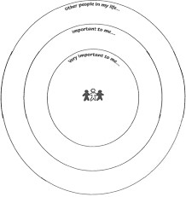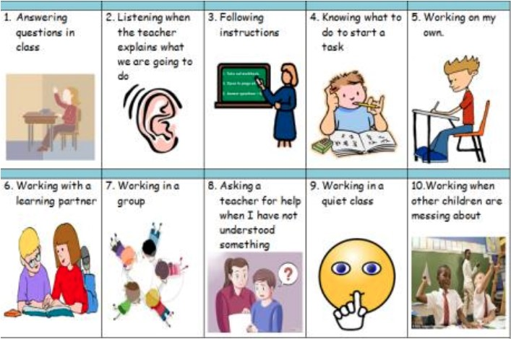

comic strip conversation Circles of Importance Mapping the landscape of fear

12. External Agencies
External agencies can offer an extra layer of expertise to advise us on how we support children to best achieve in school. At The Laurels we draw on the skills and advice of:

- The Learning Behaviour Team (Local Authority)
- The Social Communication Team (Local Authority)
- The Educational Psychology Service (Local Authority)
- The Virtual Schools Service for Children Looked After (Local Authority)
- Ethnic Minority Traveller Service (Local Authority)
- Community Mental Health Liaison Service (NHS)
- ThoughtFull - Education Mental Health Practitioners (NHS)
- Your Space Therapies
- Autism Sussex
- Reaching Families
- Speech and Language Service
- CAMHS Assessment Team
- CDC
- SENAT Special Educational Needs Assessment Team
- School Nursing Service
- Winston’s Wish
- Change Grow Live

13. What SEND is – and what it isn't
Children may experience barriers to learning, participation or wellbeing for many different reasons. Not every difficulty a child experiences means that they have special educational needs. We consider each child individually and seek to understand their strengths, needs and the barriers they may be experiencing.
English as an Additional Language (EAL)
Having English as an additional language is not, in itself, a special educational need. When a pupil with EAL is experiencing difficulties, we consider their learning and development carefully to distinguish between needs associated with learning English and possible SEND. Where appropriate, we may seek advice from specialist services.
Behaviour
Behaviour can sometimes communicate an unmet need, but behaviour alone does not mean that a pupil has SEND. Where there are concerns, we work with the pupil and their family to understand what may be contributing to the behaviour. We may use observations and other information to identify patterns, barriers and appropriate support. Where necessary, we will seek advice from specialist services.
Other circumstances
A child's circumstances, including being looked after by the local authority, experiencing disadvantage or having difficulties with attendance, do not in themselves mean that a child has SEND. However, children in these circumstances may also have special educational needs.
Where a child is looked after by the local authority and also has SEND, we work closely with carers, social workers and other professionals to ensure that their SEND provision is coordinated with their Personal Education Plan (PEP), Care Plan and other relevant plans.
In all cases, our focus is on identifying the individual child's needs and barriers accurately and providing the right support to help them participate, learn and make progress.

14. Extra-curricular Activities
SEND should not be a barrier to children attending extra-curricular activities and we ensure all clubs, trips and activities are available for all pupils.
- All of our extra-curricular activities and school visits are available to all our pupils, including our before-and after-school clubs.
- All pupils are encouraged to go on our residential trip(s).
- All pupils are encouraged to take part in sports day, school plays, special workshops
We make reasonable adjustments to enable pupils with SEND and disabilities to participate alongside their peers wherever possible. It may be necessary to conduct a risk assessment for individual pupils and sometimes pupils require additional adult support to accompany them.
Staff monitor the attendance of different groups engaging with extra-curricular activities and they will sometimes approach individual pupils to explore whether there are barriers to them accessing clubs.

15. Social and Emotional Development
Here are some of the ways we support the social and emotional development of our children:
- Our playground is supervised with a high adult/child ratio. This allows staff to support children with play activities and to intervene should there be any friendship difficulties.
- We have invested in a range of play equipment including a large sandpit, and den building apparatus, for all children to access. These support in the development of motor coordination skills as well as engaging children in fun and collaborative play.
- We have a Calm Cafe for any children who find the playground overwhelming or who want to use their playtimes for tabletop activities. The children were consulted about what they wanted in their Calm Cafe and this ensures it best meets their needs.
- We are able to access play therapy support for children who have been impacted by parental substance misuse through Change Grow Live (CGL). We also have an Education Mental Health Practitioner who works with children identified as needing emotional support.
- A Nurture Group, called Toast Club, runs before school. This supports children with a range of needs such as emotionally based school avoidance, and it also provides an opportunity for developing positive relationships in a small group setting.

16. Evaluating the Effectiveness of the Provision
We do not evaluate SEND provision simply by whether support has been delivered. We evaluate whether it is making a difference to pupils' learning, independence, participation and wellbeing.

Leaders use a range of evidence to identify what is working well, where barriers remain and what needs to change. We evaluate our SEND provision in a variety of ways, including:
- analysing standardised test data
- tracking the effectiveness of interventions half termly
- tracking progress and attainment data in core subjects on Insight termly
- analysing gaps in non-core subjects termly
- reviewing pupils’ progress towards their ILP targets each term
- holding annual reviews for pupils with EHCPs
- carrying out learning walks, work scrutiny and drop-ins
- monitoring by the SENDCo
- the SENDCo provides the Local Governing Body with termly reports and attends meetings to allow for the evaluation and scrutiny of the school’s provision.

17. Admissions
Children who have an Education, Health and Care Plan (EHCP)
If you want a place for a child who has an Education, Health and Care plan, contact your Assessment and Planning Officer at West Sussex County Council. If you want a place for any other child with special educational needs, you should apply as usual and your application will be considered in the same way as applications from children without special educational needs.

- The Laurels Primary School Admissions Policy
- School Admissions contact: admissions.south@westsussex.gov.uk. Tel:033 301 42903

Children with SEND who do not have an Education, Health and Care Plan (EHCP)
Children who have identified SEND but do not have an EHCP should apply through the normal admissions process. Additional information on the facilities and SEND provision within the school is available through our Local Offer on the website.

Admission arrangements for disabled pupils
We make reasonable adjustments to our provision, curriculum, physical environment and school activities to ensure that disabled pupils can access and participate in school life alongside their peers. For more information about how we ensure all children can access our provision, please read our school’s accessibility plan which can be found here https://laurelsprimary.co.uk/policies/ This covers
- Improving the physical environment to enable disabled pupils to take better advantage of the education, benefits, facilities and services we provide
- Improving the availability of accessible information to disabled pupils

18. Contacts of support services for parents and carers
Please visit our SEND padlet with a range of services here https://padlet.com/hpinney/a1re7f85vn01gs1j
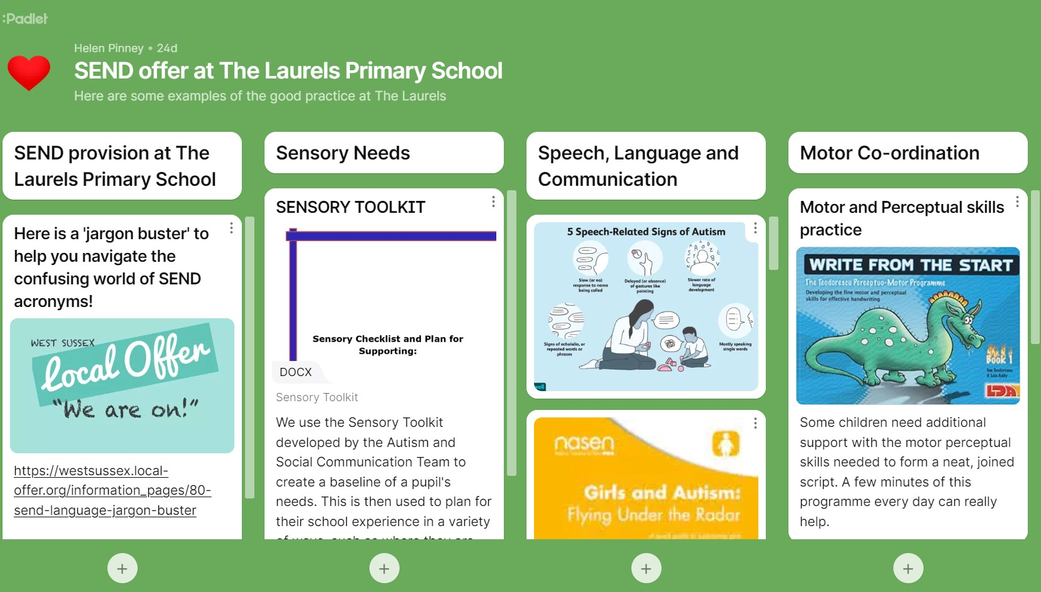

SENDIAS
West Sussex SENDIAS provide impartial information, advice and support to children and young people who have SEND (special educational needs and/ or disabilities) for those aged 0-25 and their parent carers.
If you would like to contact the West Sussex SENDIAS Service for information or advice then you can:
Call us: 0330 222 8555 (open 9am – 4pm, Mon – Fri).
Email us directly : Parent/Carers: send.ias@westsussex.gov.uk
Children and Young People: cyp.sendias@westsussex.gov.uk

Special Educational Needs Assessment Team (SENAT)
Contact Team SOUTH: Email: SENAT.South@westsussex.gov.uk Tel: 0330 2223120

Disagreement resolution and mediation
Parents and young people can access independent disagreement resolution and mediation services where there is a disagreement about SEND provision or decisions relating to an Education, Health and Care Needs assessment or plan. Information about mediation and disagreement resolution services is available through the West Sussex Local Offer. West Sussex SENDIAS can also provide impartial information and advice about the options available to parents and young people.

The Local Offer
Our local authority’s local offer is published here: https://www.westsussex.gov.uk/local-offer

19. Compliments, complaints, feedback and questions
We are always seeking to improve on the quality of education we provide for children with SEND and are keen to hear from parents about their child’s experience. We would also like your views about the content of our SEND Information Report. Compliments are always greatly received and can be passed on either directly to staff and the SENDCo, or formally recorded via our regular questionnaires to parents or in the form of a letter to the Headteacher. These positive comments may be published on our school website.
We hope that complaints about our SEND provision will be rare, however, complaints about SEND provision in our school should be made to the SENDCo in the first instance. They will then be referred to the school’s complaints policy.
Where a satisfactory conclusion cannot be reached with the SENDCo, the parent can then make an appointment to see the Headteacher, during which further information can be exchanged and procedures altered as appropriate.
If a satisfactory conclusion still cannot be reached then the Local Governing body must become involved. The school participates fully if receiving requests for information for tribunals or assisting parents in formulating appeals etc.

20. Links with other policies or documents
- Accessibility plan
- Behaviour and anti-bullying policies
- Equality information and objectives
- Supporting pupils with medical conditions policy
- Effective use of Teaching Assistants
- Child Protection Policy
- Early Years Foundation Stage
- Mental Health and Wellbeing
- SEND Policy
- Managing Medicines
Statutory policies can be found on our website: https://laurelsprimary.co.uk/

21. Monitoring arrangements
This policy and information report will be reviewed by the SENDCo every year. It will also be updated if any changes to the information are made during the year. It will be approved by the governing board.

22. Glossary of SEND terms
Term | Meaning
ADHD | Attention Deficit Hyperactivity Disorder
ASC | Autism Spectrum Condition
CAMHS | Child and Adolescent Mental Health Services
CDC | Child Development Centre
EAL | English as an Additional Language
EHCP | Education, Health and Care Plan
EP | Educational Psychologist
SaLT | Speech and Language Therapy
SENAT | Special Educational Needs Assessment Team
SEND | Special Educational Needs and Disabilities
SENDCo | Special Educational Needs and Disabilities Coordinator
SENDIAS | Special Educational Needs and Disabilities Information, Advice and Support Service

Review Schedule
Compiled/ Reviewed and Updated | Author:  Amy Elsden | Date:  August 2026
Approval By:  Charlotte Bull | Date:  September 2026 | Review Date:  Summer Term 2027

.

